**CURRICULUM VITAE**

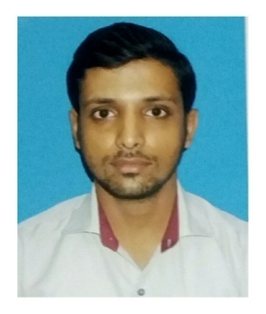

**RAHUL BABU NAIR**

**Kolkata**

**Mobile no. 9645560977**

**E-mail Id.:** [**rahul.s17779@gmail.com**](mailto:rahul.s17779@gmail.com)

**Personal Details**

Father’s Name : **Mr. Mohan Babu Nair**

Mother’s Name: **Mrs. Radha Nair**

Permanent Address : MIG/I-14, Niva Park, Phase-2

Brahmapur, Kolkata - 700096

Phone No. : 033 - 24100612

Date of Birth : December 01, 1989

Place of Birth : Kolkata

Sex : Male

Marital Status : Married

Nationality : Indian

**Passport Details**

Passport No. : N7355119

Place of Issue : Kolkata

Date of Issue : 07/03/2016

Date of Expiry : 06/03/2026

Contd…2

**Academic Qualification**

* Passed **Higher Secondary Examination (Commerce)** in 2007 under ISC Board;
* Graduated in **B.Com with Accountancy** from K.K. Das College under Calcutta University in 2010;

**Professional Qualification**

* **Knowledge of Computer – MS Office**
* **Tally 9 Version**
* **Have also worked in SAP & Oracle softwares**

**Languages Known**

|  |  |  |  |
| --- | --- | --- | --- |
| **Language** | **Speak** | **Read** | **Write** |
| English | Yes | Yes | Yes |
| Hindi | Yes | Yes | Yes |
| Bengali | Yes | Yes | No |
| Malayalam | Yes | Yes | Yes |
| Tamil | Yes | No | No |

**Organizational Experience**

* **Sales Executive** in Dewar’s Showroom, Kolkata, from February – August 2008;
* **Office Assistant** with M/s. Dynatron Services, Kolkata, from April – December 2009;
* **Commercial Assistant** with M/s. Shriram Insight, Kolkata, (an online share broking firm) from July 2010 – February 2011;
* **Accounts Assistant** with M/s. Sobha Developers Limited, Thrissur, Kerala, from December 2011 – December 2013;
* **Accountant**  with M/s. Veekesy Slipper’s India (P) Ltd., Kolkata, from January 2014 – October 2017.
* **Accountant** with M/s. Hykon India Ltd. Thrissur, Kerala from November 2017 – June 2018.
* Presently working as **Senior Accountant** with Indira IVF Hospital Private Limited, Kolkata since June 2018 onwards

Contd…3

**Job Responsibilities Handled**

* Accounts Payable & Receivable
* Bank Reconciliations
* Data Entries
* Service tax, Sales Tax & TDS related work
* Invoice Preparation (Both Purchase & Sales)
* Vendor-wise Reconciliations
* Controlling Cash Expenditures & Cash Handling
* Coordinating with Auditors
* Preparing Monthly Report & Proper Documentation
* Import Documentation works
* MIS
* Stock Auditing

**Hobbies**

Listening music,

Travelling,

Watching movies

**Declaration**

I certify that all the information stated above is correct and references are available if they are needed.

Kolkata

RAHUL BABU NAIR